The Goal
  - The tool for management of "supervised learning" process of NLP application (Supervision Tool)
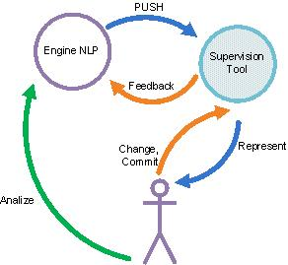

Scope
  - Stage 1 Requirements
    - The tool will accept an input from the NLP system and will be able return an output to it. Upon receiving an input, the tool will start a working cycle anew.
    - The tool will receive from the system a text and a list of expressions arranged in groups. Each group has a name. For example, the tool could receive a text of coffee machine operation manual and list of ["machine group" : ("coffee machine", "product", "machine"), "button group": ("Power button", "Control Knob")] expressions
    - The tool will depict a text on the screen
    - The tool will be able to locate expressions in the text, color them, designate them with a name of a group and provide the user with an ability to change the group of an expression
      - The user may also create a new group and be able to allocate expressions to it
    - At the end of the process, the tool will create a new, updated list of expressions
    - The rearranged list of expressions will be sent back to the system
  - Example:
Text: "After carefully unpacking your espresso machine ^{machine}, wash all removable parts with warm soapy water and rinse thoroughly. … The Power Button ^{button} will light solid blue while
New..

Machine

button

the indicator light on the Control Knob ^{button} will start to blink, indicating the machine ^{machine} is heating up."
Input Expression List : ["machine group" : ("espresso machine", "the machine"), "power group": ("Power button", "Control Knob")]
Output Expression List : ["machine group" : ("espresso machine", "the machine"), "power group": ("Power button") , "control group": ("Control Knob")]

  - Stage 2
    - The tool will be installed as a WEB service on a local machine
    - The tool will provide an interface for communicating with NLP application
      - You can chose a REST full as such an interface

  - Stage 3
    - The tool will accept an input from the NLP system and will be able return an output to it. Upon receiving an input, the tool will start a working cycle anew.
    - The tool will receive from the system a text and a list of tagged expressions.
    - The tool will depict a text on the screen
    - The tool will be able to locate expressions in the text, designate them with a color (each tag has a distinct color) and provide the user with an ability to change the tag of an expression
      - The tool will provide an ability for user to brake an expression to parts and tag each part separately
      - The tool will provide an ability for user to unite adjacent expressions and designate a distinct tag to it
    - The rearranged list of expressions will be sent back to the system

